Mobile Phone Store APP

User Manual

Contents

PREFACE 2

STARTING UP 2

I. Application Interface 2

II. Login 3

a. Registering an account 3

b. Logging in and out an account 3

III. Adding address and other account details 4

BUYER GUIDE 5

I. Navigating through the main page 5

II. Adding items to cart 5

III. Buying the items 6

SELLER GUIDE 8

I. Setting-up the store. 8

a. Create Store 8

b. Adding Items 9

c. Updating and Deleting Items 9

II. Manage your item sales 10

FURTHER HELP 11

# PREFACE

This app is created as a solution for people selling and buying mobile devices easily in few steps. In this manual, we will provide all of steps in using this application. We hope that this application will be beneficial for people that are using it.

# STARTING UP

## Application Interface

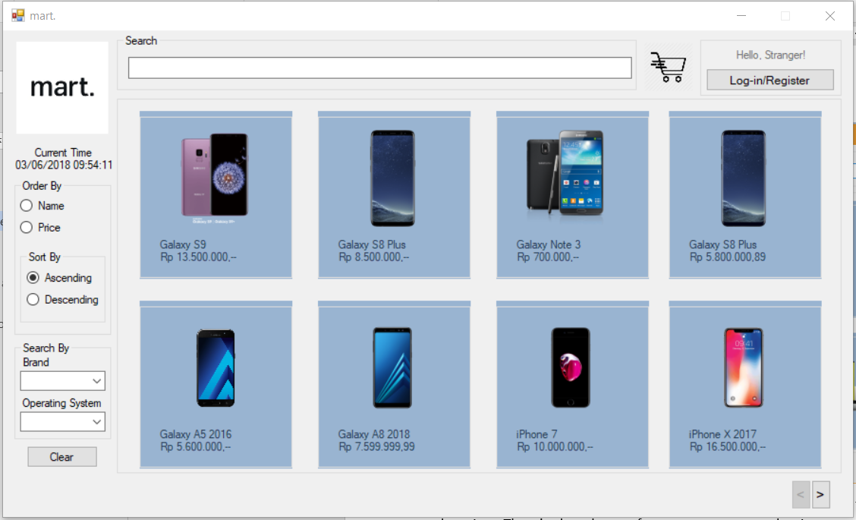

On the main page, there are search bar, log in button and the items that are on sale along with the prices. There’s also a button for next page to see other items on sale. To register an account or login, click on button. *(Skip to Step IIB, to login into the account.)*

## Login

### Registering an account

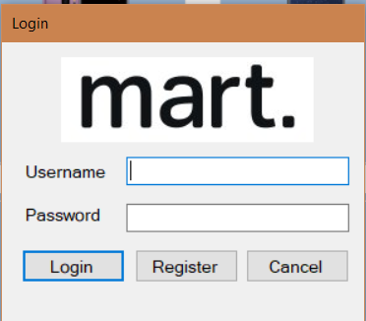On the login form, click on the Register button.

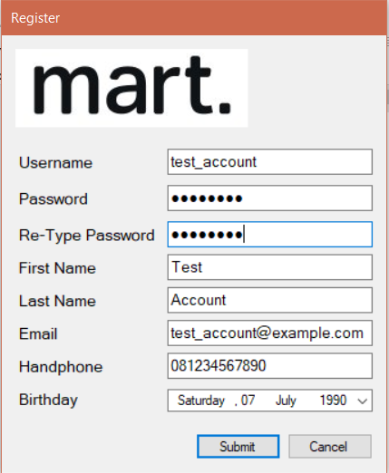

At the register form, fill out the form and submit it.

***Note***: You must fill in the password with **eight** (8) or more characters and email must use “@” and “.”.

### Logging in and out an account

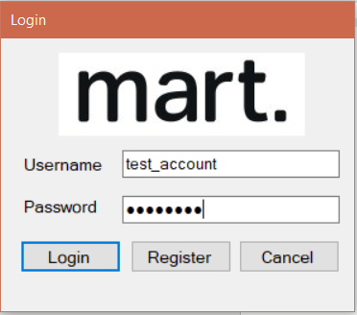To log in, you must enter your username and password that you’ve registered earlier. Then, click Login.

If the login successful, it should take you back to the main page and on the top-right corner should look like this:

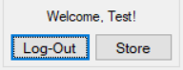

And to log out, just click that log-out button and you’re logged out!

## Adding address and other account details

Before you can buy and sell items, you need to add an address.

Click on the top-right where it shows something like this → 

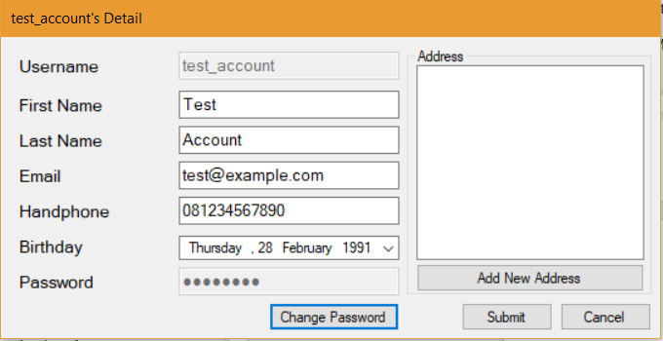

Click Add New Address and fill out the form:

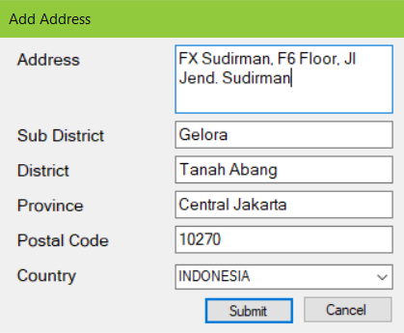Click Submit, and you’re done! To add another address, just repeat the steps.

To edit or delete an address, just click the address from the list box and change the text and click **Update** to update an address or **Delete** to delete the address.

# BUYER GUIDE

## Navigating through the main page

2

We’ll give some brief description about the main page:

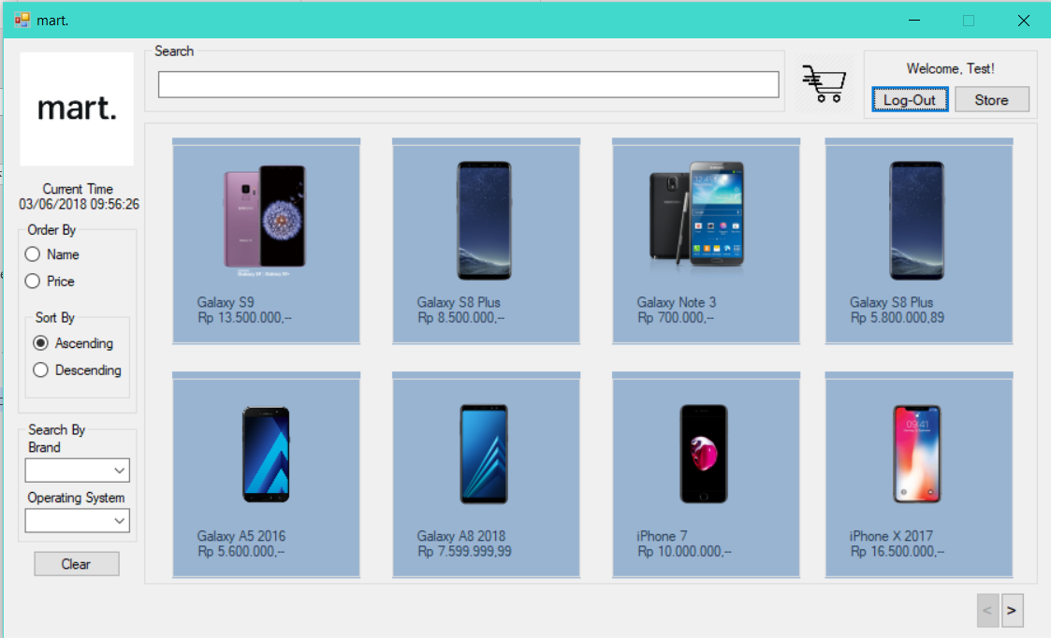

8

3

4

7

6

5

1

#### Legend:

1. Search Bar: Type in what mobile device you want to search, and it will filter out by what you searched.
2. Shopping Cart: See what item you’ve added to cart to buy it.
3. Store: To create and manage store. ***(See section SELLER GUIDE below for more information about managing store.)***
4. Items on Sale: All the mobile phones that are on sale by sellers are shown here. ***(See next section on how to buy the device.)***
5. Sort and Order: It’ll sort based order by name or price and sorting in ascending order or descending.
6. Search by Brand or OS: You can search the phone by Brand or OS.
7. Clear button: Clear all sort and searching
8. Navigation button: To navigate to the next or previous page.

## Adding items to cart

To buy mobile devices, first you need to add that mobile device to shopping cart. You can search the phone or navigate to see items that were on sale by sellers. Just click mobile devices that you want to buy, and you’ll see the item details for it:

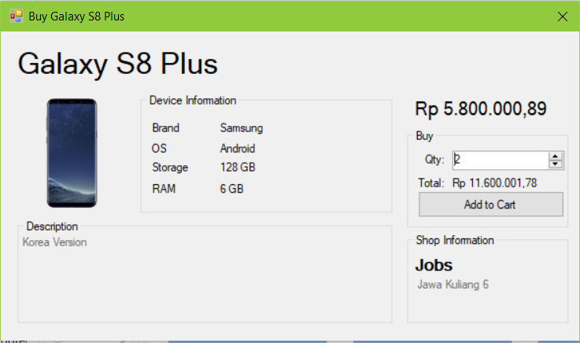

Fill in quantity you want to buy

Address

Name

You can see the title, device info, item pics, price, description and the shop information.

* Type in how much you want to buy this device in the buy box and press enter.
* You should see the subtotal price for that. In this picture it showed Rp 11.600.001,78
* You can click add to cart afterwards, to add it to shopping cart. The form will close and go back to main page.
* **Repeat steps if you want to add another device to shopping cart.**

## Buying the items

Now click the cart button  to pay for the devices that you’ve added to the shopping cart.

Your screen should look like this:

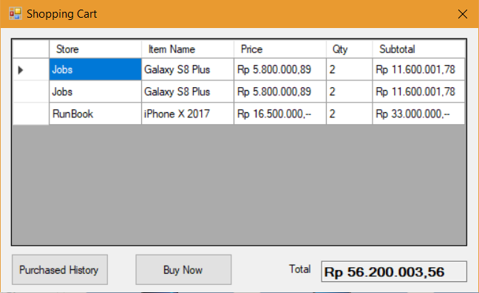You can review what you’re going to buy.

If you’re going to **remove** some items, just **click the left most column (white blank box)** in the **row** you want **to delete**. In this case, I want to remove iPhone X from my cart just click **there** and press **Delete** on your keyboard.

Click Buy Now to buy the items.

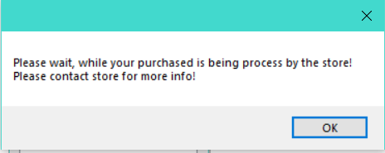 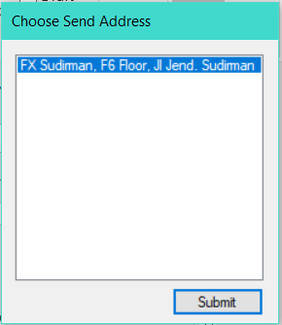Select your receiving address and click Submit. There should be a pop-up like this.

And your item will be processed by the seller.

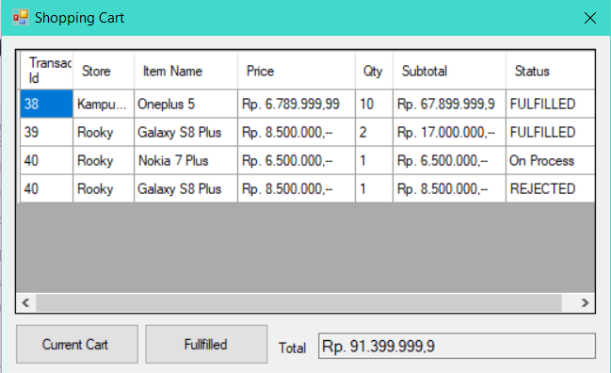You could see your past purchases history by clicking **Purchased History** and see the status of your item.

**FULFILLED** means order has been fulfilled.

**On Process** means order hasn’t been processed yet by the seller.

**REJECTED** means order can’t be processed by the seller.

# SELLER GUIDE

## Setting-up the store.

### Create Store

To create a store, it’s easy as 1-2-3!

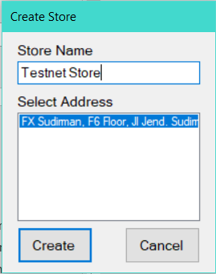Just click the **Store** button at the main page. You should see something like this:

Type in your store name and select an address as the Store Address. If you haven’t added it yet, please add it first!

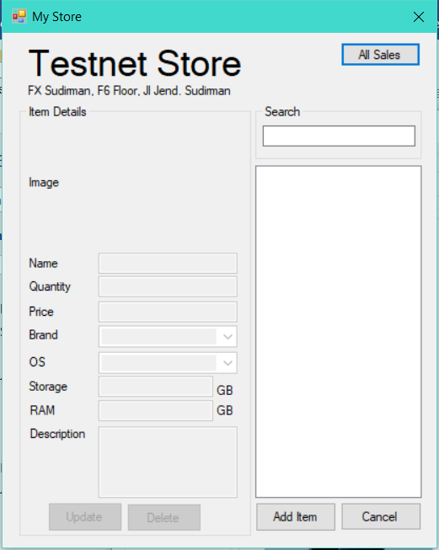After that click **Create**. You should see something like this:

### Adding Items

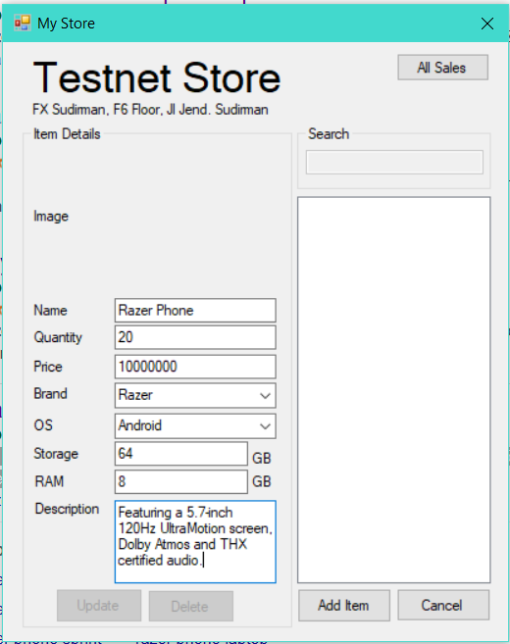To add items, simply click **Add Item** and fill out the forms.

For the Brand and OS form, you can pick out the brand or OS that have been available there or just type it if there isn’t one.

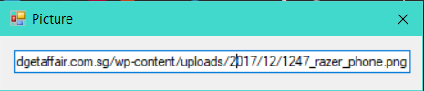To add a picture, click on the gray blank space **there** and you must input the link of the image URL. Please upload it at image hosting service and get the image URL. After inputting links, click the **close** **button** or press **Enter**.

Afterwards, there should be the image of the item that you want to sell. Then click **Add Item** again to add it or **Cancel** if you don’t want to add new one.

Your item will be published in the main page of the app. Just wait for people to buy it! ☺

### Updating and Deleting Items

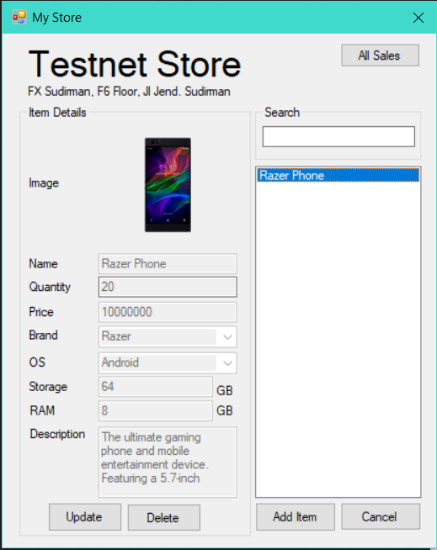

To delete, simply click the item name and click **Delete.**

To update, click item and click **Update**. Then, just edit the item the way like you add an item. Afterwards, click **Update** to update the item or **Cancel** if you don’t want to update it.

## Manage your item sales

To manage your sales, click **Store** in the main page. Then, click **All Sales** button on the most top-right. You should see something like this:

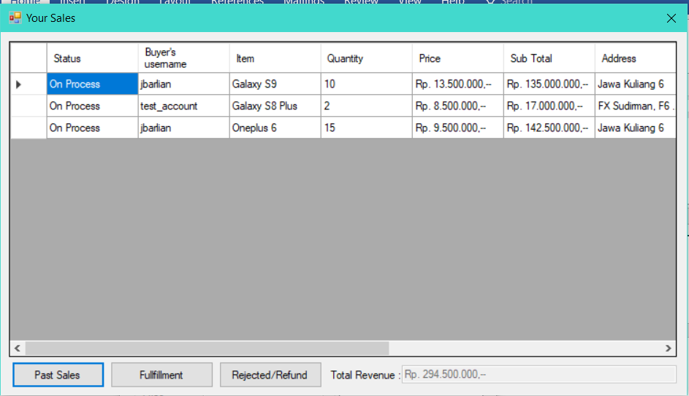To accept or fulfill the order, click the left most blank space of the row order you want to accept and click **Fulfillment**.

To reject, do the same thing but click **Rejected/Refund**. (not the Fulfillment button)

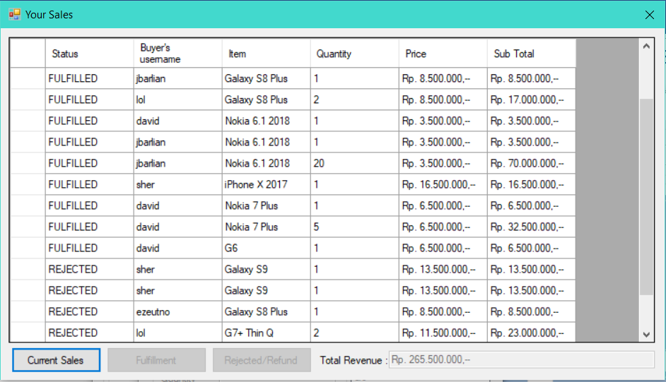You can see your sales history by clicking **Past Sales.**

**FULFILLED** means you’ve sold your item and **REJECTED** means you’ve refund their money because you reject their order.

# FURTHER HELP

Please contact devs for more info or post issue at GitHub for bugs:

https://github.com/ezeutno/DatabaseSystem-Final_Project